**I. Nature of the Business**

The business is manufacturing business. It is a product oriented business. It offers a variety of foods not only delicious but also an affordable sweets that provides happiness and well balanced meal to the consumers. The product is the output made of the business.

This business entitled ABM Sweets will offer different kinds of sweets that will surely give a delight mood to the customers. The proponents come up with this kind of business because they consider the interest of their target customers who are the students of Peñaranda National High School. They also consider the paying capacity of every student, if the set price of the products is affordable and can buy by the students. And they know that the students are sufficient in size, so that they can assure that they will have a profitable return by implementing this kind of business.

This business will offer you a quality products with affordable price that is click with your pocket and as well as to your taste. Who can resist if we are talking about sweets, the proponents know that it is the all-time favorite especially of the students, even adult can’t resist the delighting feeling of eating sweets. Eating sweets can reduce our stress. And this business will be implemented at Peñaranda National High School and obviously the target customer will be the students.

It may be common but the proponents sure that they can make profit with it. And they think of the strategies that will surely click to the prospect buyers. And they want to change the perception of many about sweets and show a unique one.

**II. CAPITALIZATION**

|  |  |  |
| --- | --- | --- |
| MEMBERS | SHARE | PERCENTAGE |
| Ellalaine Abiog | 185 | 9.5 % |
| Patricia Del Pozo | 120 | 6.2% |
| Princess Vargas | 120 | 6.2% |
| Jhoan Vicena | 120 | 6.2% |
| Edward Aguilar | 120 | 6.2% |
| Oliver Brazil | 120 | 6.2% |
| Jonathan Ferrer | 120 | 6.2% |
| Louie Hernandez | 120 | 6.2% |
| Leo Lleva | 120 | 6.2% |
| Darwin Madrid | 120 | 6.2% |
| Joshua Madrid | 120 | 6.2% |
| Reniel Madrid | 120 | 6.2% |
| Junel Maligsay | 0 | 0 |
| William Pajarillaga | 120 | 6.2% |
| Joshua Pineda | 120 | 6.2% |
| Russel Santalisis | 200 | 10.3% |

The capital of ABM Sweet’s has a total of 1,945 it is composed of 15 members who contribute to make the starting capital of the business. Capital is very vital to start up a business even if it is small or big one. The proponents must think and plan how they will allocate their resources to avoid risk or prepare themselves from risk which is inevitable. Because the resources are limited they need to become aware of so many factors that can affect their business.

**III. PRODUCTS OFFERED**

The products we sell should be the highest quality, measured not only by caliber but also by the customer’s perception of value received for money paid. We all take responsibility for the quality of our work, and continuously strive to improve.

ABM SWEETS offers yummy, festive, and joyful chocolate balls. This all-time favorite would definitely sustain everyone’s cravings for chocolates and sweets.

ABM SWEETS is prepared insanely easy but are rich. The product offers a sweet and melt-in-your-mouth snack in a reasonable price. These treats are popular not just during the holidays but year-round, loved by young and old alike.

What sets ABM SWEETS apart from other product is that the chocolate balls are rolled in sprinkle candies. Also, the product packaging is specially designed for gift-giving, perfect for any occasion.

The product can also be infused with different toppings aside from sprinkle candies such as chopped nuts, cocoa powder, or grated coconut; to be implemented on the succeeding selling activity.

It is pure, sustainable ingredients and unwavering commitment to always exceed the expectations of our customers ensures our future and provides necessary nutritional values and is available at affordable prices. In short it is “BEST QUALITY, VARIETY AND VALUE AT AFFORDABLE PRICE”.

**III.PRICING**

The ABM SWEETS are sold by piece and by box. Both have different pricing conditions:

|  |  |
| --- | --- |
| Quantity | Cost |
| 1 piece | P 5.00 each |
| 5 pcs | P 25.00 |
| 1 box (12 pieces) | P 50.00 |

For different variety of sweets like pastillas, oreo balls, graham balls coated with milk and chocolate, and lastly the combination of the three the pastigraham balls coated with oreo every piece cost P 5.00 each, for 5 pieces it costs P 25.00 and for 1 box with 12 pieces it cost P 50.00.

**IV. MARKETING STRATEGIES**

* **Product Strategy**

We have distinct flavor and look that consumers will look for. We also have different variety of sweets like pastillas, oreo balls, graham balls coated with milk and chocolate, and lastly the combination of the three the pastigraham balls coated with oreo. The proponents need to think of a very unique and catchy product for the customers/ buyers to buy the products being offered. It is one of the most important strategies to consider when someone will put up a business. In this part the proponents must also consider their target customers. Attracting customers is critical to the success of your small business. To achieve this goal, you can either throw together a makeshift marketing plan and hope for the best and you can take time to determine who is most likely to want or need what you have to sell. The analytical approach will always tip the odds in your favor.

Identifying your target audience enables you to: assess just how much demand is out there for your product or service; modify that product or service to better meet customers’ specific needs; and design a marketing campaign that “speaks to” the right people, using the tone and language most likely to appeal to them.

The target customers of this business will be the students of Peñaranda National High School. They are the ones who will consume the products being rendered to them. They are sufficient in size and can fit the production of the products produced. And they have the sufficient paying capacity, because the products being offered is very affordable. And especially it is within the interest of the consumers which is the different sweets.

* **UNIQUE SELLING PROPOSITION**

USP of our product is that our product “Abm Sweets” and its variants that innovate and create the finest, indulgent foods served here in Penaranda. We nurture the idea that our offerings are universal to all the students and people of Penaranda.

It is pure, sustainable ingredients and unwavering commitment to always exceed the expectations of our customers ensures our future and provides necessary nutritional values and is available at affordable prices. In short it is “BEST QUALITY, VARIETY AND VALUE AT AFFORDABLE PRICE”.

The strategy focused is to stay close to the customers, understanding their needs, and exceeding their expectations.

1.Its different flavors.

2.Natural origin of sweeteners and flavors.

3.High quality at economic price.

TAGLINE “**THE TASTE YOU CAN’T RESIST**”

* **Pricing Strategy**

ABM Sweet’s is priced with competition in mind. The distributors is not concerned with setting prices to signal luxury or prestige, nor it is attempting to achieve the goals of offsetting low prices by selling high quantities of products. Instead value pricing is practicing so that customers feel comfortable purchasing again the said product. The pricing strategy also makes ABM SWEETS good gifts for occasions, or “just because” it is a good presents for your friends and other relatives for their special days.

This business will offer you a quality products with affordable price that is click with your pocket and as well as to your taste. Who can resist if we are talking about sweets, the proponents know that it is the all-time favorite especially of the students, even adult can’t resist the delighting feeling of eating sweets. Eating sweets can reduce our stress. And this business will be implemented at Peñaranda National High School and obviously the target customer will be the students.

* **Distribution Strategy**

Use marketing efforts to attack the competitor in the areas in which they are not serving the market well. In this case our business is the only one which offered different kind of sweets in Peñaranda National High School. We take that advantage to make profit, we are so assured that this business will give us a profitable return.

* **Promotion Strategy**

1. Internet advertising/ social media ( ABM SWEETS facebook page)
2. Referral
3. Marketing Materials
   1. Unique Business Name
   2. Well design Logo
   3. Website
   4. Marketing Brochure
   5. Business Card

**Marketing Brochure**

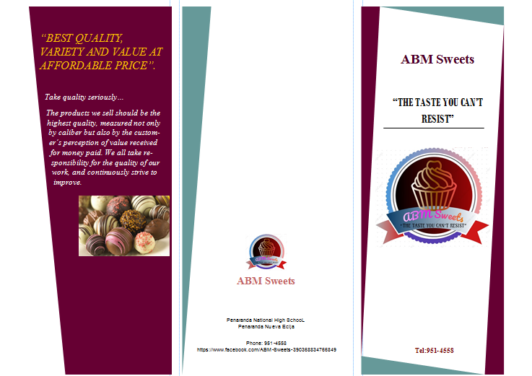

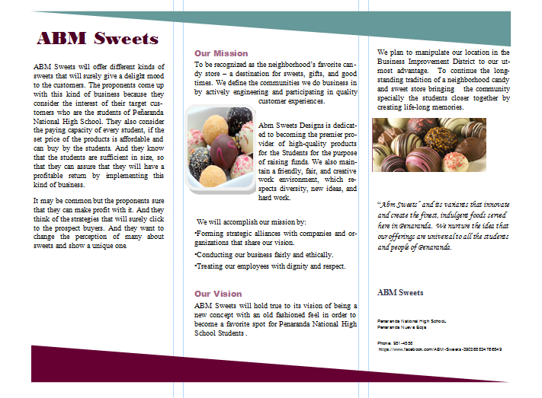

**Business Card**

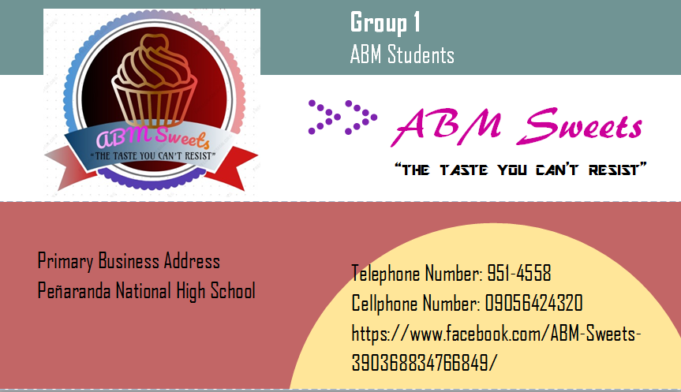

**Logo**



**V. PROBLEMS ENCOUNTERED AND SOLUTION**

Everyone has the dream of starting up their own business, and for most people it always stays a dream due to the many obstacles faced in starting a business and more so keeping it running and profitable. Some key hurdles that all entrepreneurs and business owners face when starting a business are:

* **Poor Planning**

Many business fail in the first year due to poor planning and preparation before declaring themselves as “OPEN FOR BUSINESS!” Before launching any business everything from suppliers to rates should be investigated. Noticing a hike in unexpected costs after you have just launched a business can bankrupt the plans in no time. Extra time should be taken ensuring that everything is covered, the best way to do this is by creating a comprehensive business plan.

(Solution) For the business this is a constant process of continually devising business plans and development plans for their brands, and therefore it comes as second nature. Businesses work very closely developing individual business plans to ensure their business aims work well within the business model they have invested into. A easy way to think of it is they’ve done it before, they’ll do it again!

* **Finding Customers**

Finding prospective customer.

(Solution) If the product/service adds value to people’s life, business don’t need to spend a huge amount of money on advertising in the initial stages. If the business have a great product/service, people will automatically come to you. Just remember to keep your patience and approach only those people who show interest in your product/service.

* **Time Management**

 Time management is probably the biggest problem, especially for the students like us. In our business, we need to take care of everything unlike a regular job where you only have to take care of certain tasks.

(Solution) To enhance your time management skill. Following are some useful tips:

Create goal lists: Make a lifetime goals list and break it down to annual, monthly, weekly and daily goals. That way, your daily goal will be in front you and you just have to be on track.

Delegate the jobs that don’t require your personal involvement.

Simply eliminate the unnecessary tasks.

Assess yourself on a regular basis.

* **Choosing What to Sell**

One of the biggest reasons for the failure of new entrepreneurs is selection of the wrong niche.

(Solution) It’s very common that being a newcomer in the entrepreneurial world, we don’t have the adequate expertise to select a profitable niche. In that case, ask a teacher who knows about marketing e.g. the field you want to do business in, and prepare a report of profitable niches. You can then analyze the report and decide on your preferred niches.

**Strategies for Market**

Unaware about the best possible way to market the products/services. We aim is to maximize our ROI with effective and targeted marketing.

(Solution) Again, it’s a useful idea to outsource the marketing part to another third party who has adequate expertise. Prepare a marketing budget and hand it over to them and they’ll chalk out an efficient marketing plan. Remember not to take the chance of experimentation at this stage. You can perform that later when you’ve a productive baseline.

**VI. SUMMARY OF FINANCIAL REPORTS**

**ABM SWEETS**

**Income Statement**

**For the Month ended of January, 2018**

Sales ­­­­­_______________________________________________________P 6,980

Cost of Sales _________________________________________________(3,621.45)

Gross Profit _________________________________________________­­_3,358.55

Other Operating Expense

Gas and Oil Expense_____________________________________(120)

Net Income _________________________________________________P 3,238.55

**INTERPRETATION**: For the month ended of January, 2018 ABM Sweets has a total sales of P 6,980 while the total cost of sales is P 3,621.45. Then we can get the gross profit by subtracting the total sales and total cost of sales. And the gross profit is P 3,358.55, and other operating expenses are expenses that are not direct to the production of the business product like gas and oil expense which cost 120. All expenses will be less to the profit to know if the business will have a net income or net loss. In this case ABM Sweets has a net income of P 3,238.55.

**ABM SWEETS**

**Income Statement**

**For the month ended of February, 2018**

Sales ­­­­­_______________________________________________________P 5,525

Cost of Sales _________________________________________________(3,037.50)

Gross Profit _________________________________________________­­_2,487.50

Other Operating Expense

Gas and Oil Expense____________________________________ _(80)

Net Income_________________________________________________ P2,407.50

**INTERPRETATION**: For the month ended of February, 2018 ABM Sweets has a total sales of P 5,525 while the total cost of sales is P 3,037.50. Then we can get the gross profit by subtracting the total sales and total cost of sales. And the gross profit is P 2,487.50, and other operating expenses are expenses that are not direct to the production of the business product like gas and oil expense which cost 80. All expenses will be less to the profit to know if the business will have a net income or net loss. In this case ABM Sweets has a net income of P 2,407.50.

**ABM SWEETS**

**Income Statement**

**For the month ended of March, 2018**

Sales ­­­­­____________________________________________­____________P 1,105

Cost of Sales ____________________________________________________(676.25)

Gross Profit ________________________________________­­­­­_­­­____________429.75

Other Operating Expense

Gas and Oil Expense_______________________________________ (20)

Net Income____________________________________________________ P 409.75

**INTERPRETATION**: For the month ended of March, 2018 ABM Sweets has a total sales of P 1,105 while the total cost of sales is P 676.45. Then we can get the gross profit by subtracting the total sales and total cost of sales. And the gross profit is P 429.45, and other operating expenses are expenses that are not direct to the production of the business product like gas and oil expense which cost 20. All expenses will be less to the profit to know if the business will have a net income or net loss. In this case ABM Sweets has a net income of P 409.75.

Summary of Income Statement from January to March

**ABM SWEETS**

**Income Statement**

**For the first quarter ended, 2018**

Sales ­­­­­____________________________________________­____________P 13,610

Cost of Sales ___________________________________________________(7,335.20)

Gross Profit ________________________________________­­­­­_­­­____________6,274.80

Other Operating Expense

Gas and Oil Expense________________________________________ (220)

Net Income____________________________________________________ P 6,054.80

**INTERPRETATION**: For the first quarter ended, 2018 ABM Sweets has total sales of P 13, 610 while the total cost of sales is P 7,335.20. Then we can get the gross profit by subtracting the total sales and total cost of sales. And the gross profit is P 6, 274.80, and other operating expenses are expenses that are not direct to the production of the business product like gas and oil expense which cost 220. All expenses will be less to the profit to know if the business will have a net income or net loss. In this case ABM Sweets has a net income of P 6, 054.80.

**VII. DOCUMENTATION**

